EXNO: 3
Designing a Quarter wave transformer by varying following
parameters
a) frequency
b) input impedance
c) characteristic impedance
Test case 1
Design a quarter-wave transformer for an input impedance (Zin) of 50 ohms and aload impedance (ZL) of 100 ohms. Analyze the transformer's performance as theoperating frequency is varied across {100 MHz, 200 MHz, 300 MHz, 500 MHz}.
PROGRAM:
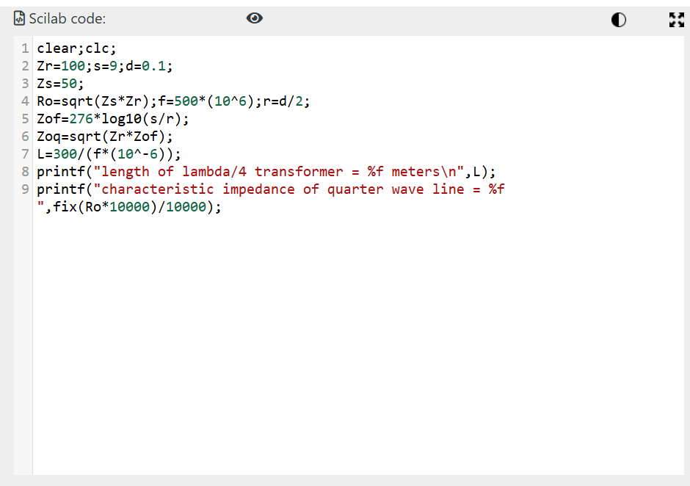
OUTPUT:
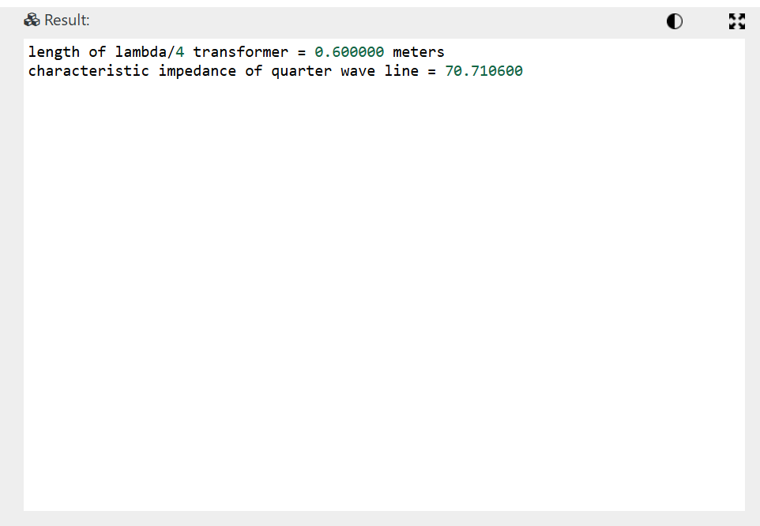

Test Case 2:
For a fixed operating frequency of 2 GHz and a load impedance (ZL) of 100 ohms,
design a quarter-wave transformer and evaluate its performance as the input
impedance (Zin) varies through {25 ohms, 50 ohms, 75 ohms, 100 ohms}. Validate
that the transformer's characteristic impedance (Ztransformer= Ro= sqrt(Zin⋅ZL)
changes with Zin.
PROGRAM:
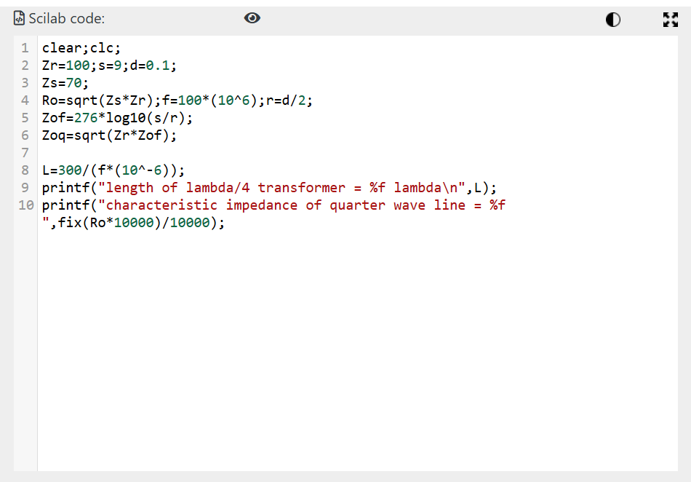
OUTPUT:
